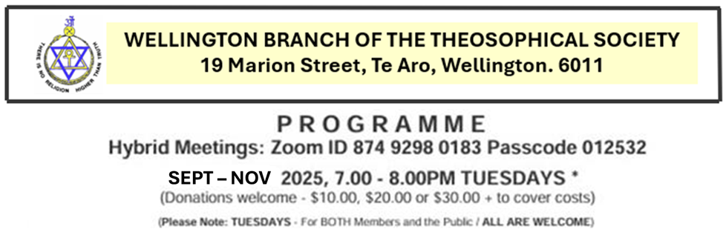
DATE | DAY | TIME | SUBJECT | Presenter/s
THEOSOPHICAL POTENTIALITIES
SEPTEMBER 2025
02 Sept | Tue | 7-8pm | Varieties of Consciousness | Donna Williard-Moore
06 Sept | Sat | 2-4pm | Healing Service and Members Meeting | Simon Webber
09 Sept | Tue | 7-8pm | Creating the nucleus of a society of divine wisdom | Simon Webber
16 Sept | Tue | 7-8pm | The inner side of rituals and ceremonies | Sushma Webber
20 Sept | Sat | 2-4pm | Healing Service and Members Meeting | Simon Webber
23 Sept | Tue | 7-8pm | Fast train to Nirvana | Kirsty Morton
30 Sept | Tue | 7-8pm | Carl Jung: Helping us to understand ourselves | Pam Stainton
OCTOBER 2025
04 Oct | Sat | 2-4pm | Healing Service and Members Meeting | Simon Webber
07 Oct | Tue | 7-8pm | Annie Besant’s Birthday | Sushma Webber
14 Oct | Tue | 7-8pm | Theosophical Potentialities | Bill Keidan
18 Oct | Sat | 2-4pm | Annual General Meeting | Simon Webber
21 Oct | Tue | 7-8pm | Sisterhood – A personal journey | Pam Stainton
28 Oct | Tue | 7-8pm | Unfolding the human potential | Vibha Saksena
NOVEMBER 2025
01 Nov | Sat | 2-4pm | Healing Service and Members Meeting | Simon Webber
04 Nov | Tue | 7-8pm | Summary of Years Teachings | Simon Webber
11 Nov | Tue | 7-8pm | Christmas Party | Simon Webber
15 Nov | Sat | 1-8pm | Foundation Day – 150 Year birthday celebration | Simon & Sushma Webber
16 Nov | Sun | 10am-4pm | Foundation Day – 150 Year birthday celebration | Simon & Sushma Webber
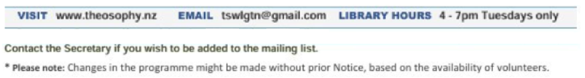

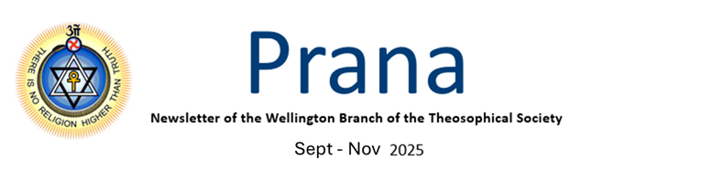
Dear Members

Welcome to our third term (September to November) of theosophical service and lodge activity.
For this term, we are focusing on theosophical potentialities looking into the human potential and what we can achieve as part of our service in the Theosophical Society (TS). This includes different manifestations of consciousness, our work in the TS, symbology, sister hood and other areas listed in the programme.

This term, and our year, will culminate with our 150th year birthday party on Foundation Day. We will have a weekend event, with many presenters, including international speakers. Registration is required – contact Pam Stainton, Secretary: secretarytswlgtn@gmail.com, along with $20 registration fee to cover dinner on Saturday night and lunch on Sunday.

Healing Services and Members meetings continue fortnightly.

Annual General Meeting: Notice
The Annual General Meeting of the Wellington Branch of the Theosophical Society Inc. will be held on Saturday 18 October, at 2.00pm at 19 Marion Street, Te Aro, Wellington. A Zoom link will be circulated to enable those unable to attend in person to participate. Members only.

Earthquake Strengthening
I am pleased to let you know that the earthquake strengthening will begin early September. What I can also say, as part of this work, we will be getting the front of the building painted, which will look very nice. It will be in the same colour as we currently have. Everything should be completed by 10 October at the latest.

New Plymouth Regional Event – Saturday 27 & Sunday 28 September
New Plymouth Lodge are hosting a Central Regional event, 27-28 September 2025. All are welcome. Registration of $50 members/ $60 non-members is required, and places are limited. Registration opens 1 September 2025. Details will be included in the weekly Mailchimp Zoom invite on this date.

Subscriptions – Due now
New changes to the Sections Constitution requires that members pay their annual membership fee at the start of the financial year (1 October). So, can you please pay your membership fee by 1 October 2025 (for the 2026 year).
Partners: $80 Single: $50 Unwaged/Student: $30

Account Name: Wellington Lodge of the Theosophical Society
Account Number: 38-9007-0433248-00

I wish you all a very happy and wonderful time over our next term of service. May the Masters continue to guide us in our work.

